# CSE3501-Information Security Analysis and Audit

# Lab 9+10

# Digital Assignment-2

# Submitted by: Alokam Nikhitha

# Reg No:19BCE2555

# Privilege Escalation in Linux OS using sudo command on terminal.

# whoami:

returns the user Details

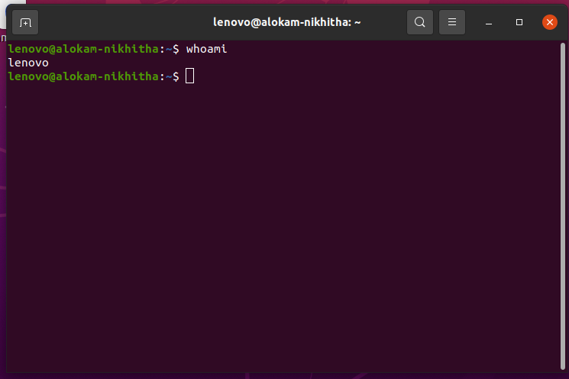

sudo –l:

returns list of commands the user can use or the user even has a permission to use the sudo command.

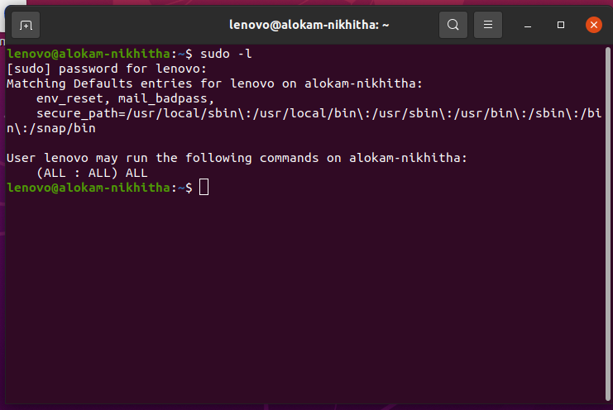

sudo -i command to get to the root user which has higher privileges than the user dgn, to confirm that the user is changed check it using whoami command. Thus, Privilege Escalation is achieved.

